SwipeEd Canvas — Nodes & Navigation
How a playable game node lives on the dotted-paper corridor
Interaction & affordance spec · The Equal Lens canvas system · June 2026
Sits beneath the Chapter Canvas Theming (design approach) doc and the per-chapter content docs/JSON
“If it lifts off the page, you can play it. If it’s drawn into the page, you read it.”

Contents

(In Word: right-click → Update Field to populate page numbers.)

1. Purpose & where it fits
The chapter content docs say what each node teaches (myths, truths, doodles, stickers). The design-approach doc says what the canvas is (dotted paper, Lensy, UN & RE, light/dark). This doc fills the gap between them: how a node tells the player ‘this is a game you can play’ without ever breaking the hand-made canvas. It is the affordance and navigation layer for the developer build.
One rule governs everything here: depth means interactivity. On a scrapbook, two things sit at two heights — marks drawn into the paper, and stickers/cut-outs pinned on top of it. We use exactly that. Anything lifted off the page (a hard offset shadow) is tappable; anything drawn flat into the page is there to read. Learn it once, and all 77 nodes across eight chapters are self-explanatory.

2. The two-layer model
The corridor is a single sheet of dotted paper that scrolls — not a 3D hallway. There is no space beneath it for anything to float in, and no second material (no shelf, tray, glass, or card panel) on top of it. Everything lives in just two layers, and the entire depth budget of the product is one sticker’s lift.
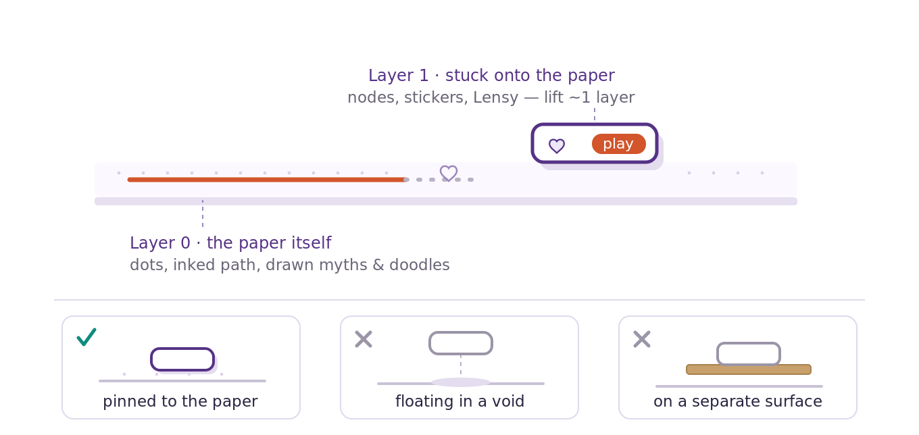
Fig. 1 — Nodes are stuck onto the paper (Layer 1), not floating in a void and not on a separate surface.
Layer 0 — the paper itself. The dotted texture, the inked path, the struck myths and written truths, and the ambient doodles. All flat, no shadow. This is content: it is read, not tapped.
Layer 1 — stuck onto the paper. Game nodes, earnable stickers, and Lensy. Each lifts about one layer via a hard offset shadow (no blur, no glow on the light canvas). This is interactive: it is tapped.
The lift is tiny and consistent. A node sits a few ‘millimetres’ proud of the page, like a sticker — never hovering. Same offset everywhere, so the eye reads ‘pinned, therefore tappable’ instantly.

3. The node is the learning loop
A node isn’t a button glued onto the canvas — it is the Unlearn → Relearn → Grow loop made visible. Its three lifecycle states reuse one asset each chapter already defines per game: its single earnable sticker (keyed by node_id in stickers[], verified 1:1 with the game nodes across all eight chapters). The node uses that sticker’s motif as its glyph.
- Locked = the myth, not yet corrected. The game’s sticker motif is drawn faint and sketchy, flat on the page — un-inked.
- Active = the pencil at work. Fully inked cut-out, lifted, Lensy inviting — RE is writing.
- Done = grown. The earnable sticker is stuck on; the myth beneath fades to a ghost under its truth.

4. Node states (the core table)
Four states. Only one — Active — carries a strong ‘play’ cue, so the corridor never shouts.
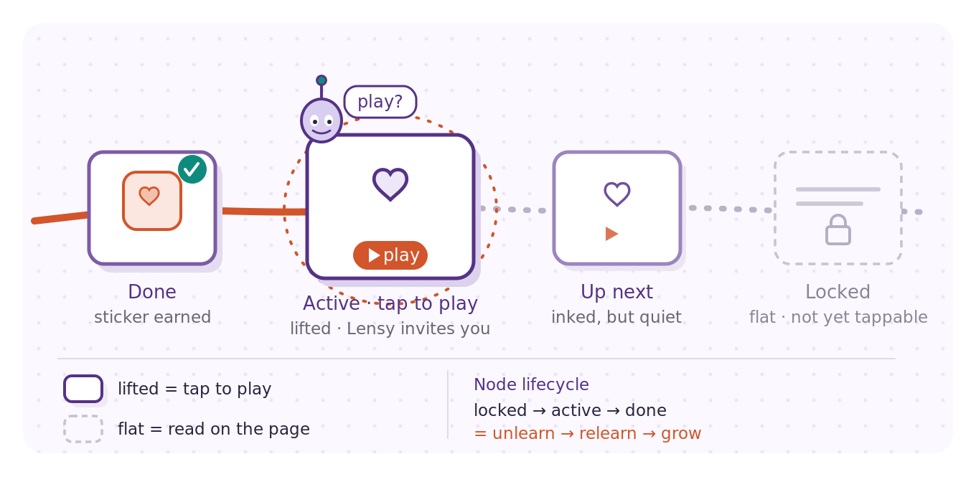
Fig. 2 — The four node states on a stretch of light (kids) corridor.
State | What the player sees | Reads as
Locked | The game’s sticker motif drawn faint; flat on the page (no shadow); dashed/pale outline; the myth still sits uncorrected. | Not yet reachable — read-only for now
Up next | Inked cut-out, lifted, but quiet: no Lensy, no ring; a small drawn play mark and the game’s sticker motif. | Playable, but not the one to do now
Active | Fully inked cut-out, lifted; a hand-drawn ring keeps re-sketching itself; Lensy perched on it with a ‘play?’ bubble. | Play me next
Done | Earnable sticker stuck on + a tick; the corrected myth shown as a faint ghost beneath its truth. | Completed

Current vs optional. Exactly one node is Active (the next in the linear chain). Earlier unlocked nodes drop to ‘Up next’ styling so players can replay without the whole path competing for attention.

5. Node anatomy
Every node carries two signals at once — what the game is, and that it’s playable:
- The cut-out / tile — the lifted surface itself (the affordance). See §8 for the kids-vs-adults shape decision.
- The node glyph — the game’s earnable-sticker motif (traffic light, compass, Boundary Bot…), hand-drawn inside; node-keyed 1:1. Tells the player what it’s about, and is the same motif through all three states.
- The play mark — a small drawn triangle / pencil-tip. Tells the player it’s playable, not just décor.
- Lensy + speech bubble — only on the Active node. The mascot doing the inviting is the strongest, most on-brand ‘play’ cue we have.
- On Done the motif becomes the full-colour sticker, ‘stuck on’ with a tick. Stickers are the only reward currency (no crowns or coins from other games).
- Ambient doodles — the chapter’s décor motifs (the doodles[] array, role: ambient) live on Layer 0 as texture; they are not part of any node.

6. The path & progress
The dotted texture of the paper doubles as the path between nodes — no separate UI rail. Progress is drawn, not metered:
- Ahead of you: the path stays dotted (the page, not yet walked).
- Behind you: it inks over in Grow Coral — a solid hand-drawn line traces the route you’ve completed. The corridor is literally being drawn in behind the player; this replaces any progress bar.
- Capstone landings are wider ‘clearings’ in the corridor — a sticker-book spread, not a node (see each chapter’s capstone landing).

7. Motion & feedback
Motion is sketch-like, never glossy. No bouncing 3D buttons, no shine.
Active node. The hand-drawn ring is animated as if an invisible pencil keeps re-drawing it (a looping stroke-dash ‘sketch’), and Lensy idles — blink, small tilt.
Completion beat. On a correct answer the loop plays out literally: UN erases the struck myth, RE writes the truth, then the earnable sticker drops onto the node. Unlearn → Relearn → Grow, every time.
Restraint. One moving thing at a time per screen. The path-ink animates once on completion, not continuously.

8. Light vs dark canvas (and the node shape)
The light→dark flip at Chapter 6 changes the mood, not the rules. Same two layers, same lift, same lifecycle — only the surface and the shadow treatment differ.
 | Kids · light (Ch.1–5) | Adult · dark (Ch.6–8)
Paper | Warm off-white (#FBF9FF) on faint violet dots | Deep ink (#15131F) on faint light dots
Lift cue | Hard offset shadow (paper-on-paper) | Soft offset glow (still an offset, never a float)
Node shape | Free cut-out sticker — irregular, playful | Raised paper tile — neat ‘page-within-the-page’
Why | Scrapbook playfulness suits young players | Calmer grid + bigger tap targets for text-heavier adult nodes

Decision locked: free cut-outs for the kids’ light chapters, raised tiles for the adult dark chapters. Both obey the lift rule, so the affordance is identical even though the silhouette differs.

9. Accessibility & fallback
- Never colour-only. Every state also carries a text label — ‘Play’, ‘Done’, ‘Locked’ — and a shape/shadow cue, so the system works without colour vision.
- Reduced motion. The sketch-ring and sticker-drop fall back to static inked states; nothing essential is animation-only.
- Small screens. The corridor collapses to a vertical list of cards that keep the cut-out shadow + signature doodle + text state label — the depth affordance still carries.
- Tap targets & contrast. Minimum 44×44 px touch target per node; dark-canvas text/stroke meets WCAG AA contrast. Audio narration remains available throughout (carried from the chapter docs).

10. Guardrails (do-nots)
- No gradients, blur, soft drop-shadows or glow on the light canvas — only the hard offset cut-out shadow.
- No rounded-rect ‘app buttons’, no flat material/SF icons — doodles are hand-drawn.
- No literal progress bars, XP bars or streak counters on the corridor — the inked path is the progress.
- No reward art borrowed from other games — earnable stickers are the only currency.
- No second surface (shelf, tray, glass, card panel) and nothing floating — one sheet of paper, two layers.

11. Tokens & hand-off
Colours. Equal Violet #553286 (node outline / Lensy), Insight Teal #0F8B7E (UN eraser), Grow Coral #D2552B (RE pencil, inked path, play mark), paper #FBF9FF (light) / ink #15131F (dark).
Shadow. Offset only: ~ +5px x, +6px y, no blur, fill a light violet-grey on the light canvas; a low-opacity glow-offset on the dark canvas. This single value is the ‘interactive’ signal — keep it constant.
Type. Baloo 2 for Lensy speech & node titles; Nunito Sans for body; Poppins for UI labels (per brand v2.1).
Data tie-in. Each game node has exactly one earnable sticker keyed by node_id in stickers[] — verified 1:1 across all eight chapters. The node uses that sticker’s motif as its glyph: faint when Locked, inked when Active, full-colour and ‘stuck on’ when Done. The doodles[] array is ambient chapter décor for Layer 0 (role: ambient) and is not node-keyed — so no changes to the chapter JSONs are needed.
Figures 1 and 2 above are the canonical reference renders. They depict the light (kids) canvas; the adult chapters apply the same system on ink paper with raised tiles and the glow-offset lift.

